**Doorways, Inc.**

P. O. Box 295

Seekonk, MA 02771

doorwaysfoodpantry.org

DoorwaysFoodPantry@gmail.com

**I want to donate food.**

Here is a short list of groceries that you, a business, school, church, club or group may wish to consider as a guide when considering donating food or when hosting a Food Drive on behalf of Doorways, Inc. These are items most frequently needed.

Canned baked beans

Canned Beef stew

Canned Progresso beef soup or chowders

Canned fruit (fruit cocktail, peaches, pears, pineapple, etc.)

Cereal & Oatmeal

# Chef Boyardee Spaghetti & Meatballs or Ravioli

Rice-a-Roni products

Spaghetti sauce in plastic container

Pancake Mix

Bake mixes (cake, muffins, cookies, breads, cupcakes, etc.)

Canned potatoes and beets

Snacks (crackers, cookies, Jell-O’s, nuts, chips, granola bars, etc.)

*NOTE: 4 oz. cans or/smaller size items are welcome for our seniors.*

**Seekonk Donation Drop-Off Locations**

1. Doorways Pantry, North School, 2 North Street.

Every Saturday from 8-10am

1. Stop & Shop at Baker's Corners, 1475 Newman Avenue
2. Stop & Shop, Route 6, 125 Highland Avenue
3. Seekonk Public Library, 410 Newman Avenue
4. Seekonk Human Services, 540 Arcade Avenue

**Like our Facebook Page Make a Donation**

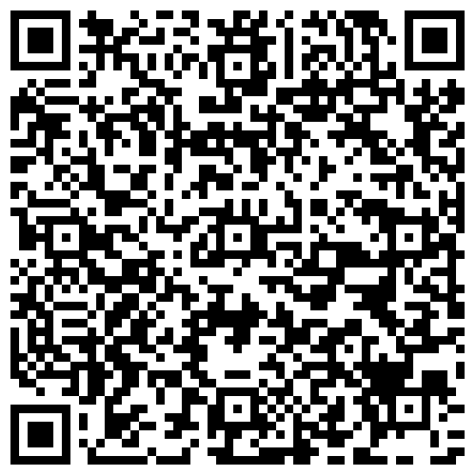 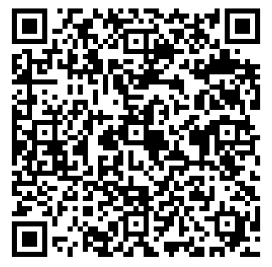

**Have any questions or wish to make drop-off arrangements?**

Please email at DoorwaysFoodPantry@gmail.com or call us at

508-761-6380.



**Message from Family**

**served at Doorways**

“Blessings to all of the donors to the food pantry. Without your generous help, my family would have truly struggled over these last years. Know your donations are heaven sent from your hearts.”

− Rachel

**Board Members**

Doug Hayward, Chairman

David Francis, President

Wendy Ashcroft

Emily Fasteson

Diane Fox

Francis Gallishaw

Polly Hayward

Larry Hindle

Paul Hodge

Gerard McCabe

Suzie Miller

David Mullen

### **About Doorways**

Doorways, Inc. is a 501(c)3 non-profit organization addressing hunger and food insecurity. Our Federal Tax

ID# is 04-3581848.

Rev. 2/2024